# The Inside Scoop

EMS3O1

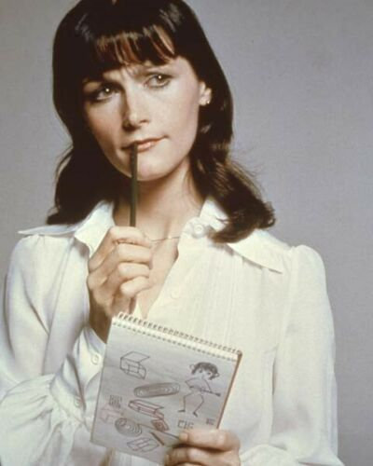The point of this assignment is to present in a colourful, descriptive, organized, specific, entertaining way, how a now-famous media work was made. It can be a film, a TV pilot or series or a music album. The ones we looked at in class are best for marking purposes. Use this instruction page as a template for your finished assignment. Type right on it. Formatting marks hang in the balance.

Organize your assignment into sections like the boxes on the planning sheet, using blue bold headings as seen on this sheet. Try for three sections, three situations/stories, for a mark of no greater than 75%, and more than that if you’re trying for a higher mark than that. (3 x 3 is 9. 4 x 3 is 12). A good definition of a story is someone wanting something and overcoming obstacles to achieve it. For example:

In making the *Monster Hunters* movie, fictional writer/director Boris Zuckerman made particularly creative choices, to deal with these obstacles (that’s an introductory sentence. Do one like it to start your assignment):

## Limited budget

## No computer special effects

## Casting (e.g. The death of the actor he wanted to cast in one of the lead roles)

## Location and Set (e.g. A fire destroyed part of the set)

If you found three stories/creative choices relating to each, you can do a heading for each of those four areas, with your three stories plugged in under the appropriate headings.

Use the Internet, particularly YouTube interviews with people involved in the project, and [www.imdb.com](http://www.imdb.com) to fill your assignment with specifics.

## Concluding Section

In this brief section, use specifics to make a case for this media work ending up being a huge, lasting success.

## Sources

Dazzle me with how many different sources you used, starting with a documentary or DVD commentary track with whomever it was.